Natural Shape Words – Pictures (3 of 3)

**13. Ichthyomorphic // Fish shaped**

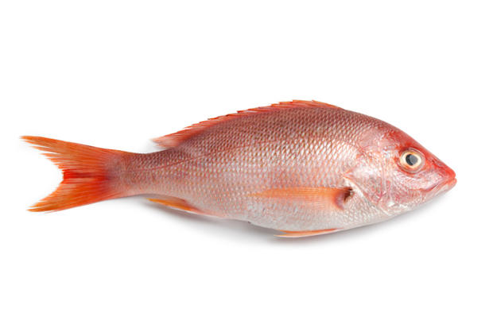

**14. Lachrymiform // Tear shaped**

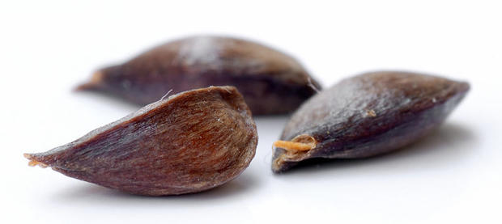

**15. Reniform // Kidney shaped**

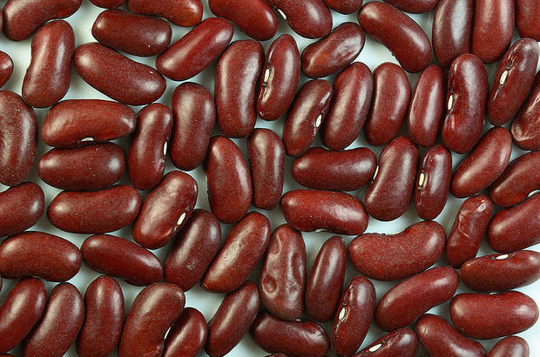

**16. Scaphoid // Boat shaped**



**17. Scyphoid // Cup shaped**

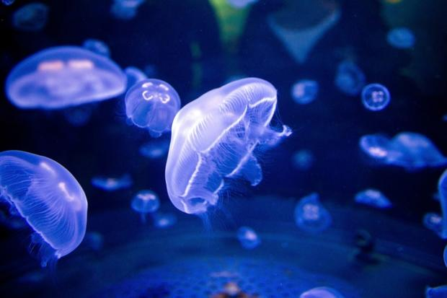

**18. Xiphoid // Sword shaped**

